WEEK 4

QUERY 1

Find all the customer who have an account at all the branches located in a specific city. ( Ex: Delhi)

select customer_name  
 from depositor d,bank_account ba, branch b  
 where d.accno=ba.accno and b.branch_name = ba.branch_name  
 and branch_city = 'Delhi'  
 group by customer_name  
having count(distinct ba.branch_name) = (select count(*) from branch b where branch_city='Delhi');

OUTPUT

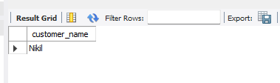

QUERY 2

Find all customers who have a loan at the bank but do not have an account.

create table Borrower(Customer_name varchar(20), Loan_number int,

foreign key(Customer_name) references Bank_customer(Customer_name),

foreign key(Loan_number) references Loan(Loan_number));

insert into Borrower values("Avinash",1),("Dinesh",2),("Mohan",3),("Nikil",4),("Ravi",5);

select distinct b.Customer_name from Borrower b, Depositer d

where b.Customer_name not in(

select d.Customer_name from Loan l,Depositer d, Borrower b

where l.Loan_number=b.Loan_number and

d.Customer_name=b.Customer_name );

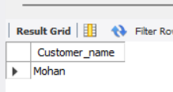

QUERY 3

Find all customers who have both an account and a loan at the Bangalore branch

select distinct d.Customer_name from Depositer d

where d.Customer_name in( select d.Customer_name from Branch br,Depositer d, Bank_account ba

where br.Branch_city="Bangalore" and br.Branch_name=ba.Branch_name and ba.Accno=d.Accno and d.Customer_name

in( select Customer_name from Borrower));

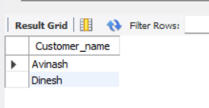

QUERY 4

Find the names of all branches that have greater assets than all branches located in bangalore.

select Branch_name from Branch

where Assets > (select max(Assets) from branch where Branch_city='Bangalore');

OUTPUT

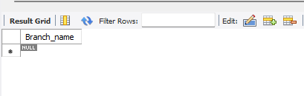

QUERY 5

Demonstrate how you delete all account tuples at every branch located in a specific city (Ex. Bombay)

delete from Bank_account ba

where ba.Branch_name in(Select Branch_name from Branch where Branch_city='Bombay');

select * from Bank_account;

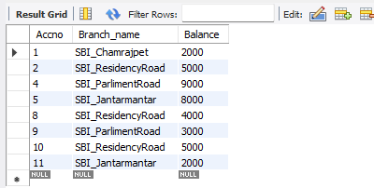

QUERY 6

Update the Balance of all accounts by 5%

update Bank_account

set Balance=(Balance+(Balance*0.05));

select * from Bank_account;

